  
 ***FINAL PROJECT REPORT   
  
COURSE TITLE :* *Microprocessors and Microcontrollers Lab  
COURSE CODE : CSE 360***  
 ***Submitted To :***  
 **Md. Ismail   
 Lecturer,  
 Department of Computer Science and Engineering,  
 University of Information Technology & Sciences  
 (UITS)**



Submitted By ***:*  NAME : Tonny Talukder ID Number : 0432220005101050**   **Section : 6A1  
 Batch : 52  
 Department : CSE**

***DATE OF SUBMISSION : 26/05/2025***

### Disk-Based Calculator for Two-Digit Arithmetic Operations using EMU8086

### 1. ****Introduction****

This project is a **disk-based calculator** developed using **EMU8086 assembly language**. It performs basic arithmetic operations (addition, subtraction, multiplication, and division) on two-digit numbers and saves the result to a disk file.  
  
**2. Tools Used : EMU8086 Microprocessor Emulator**

### 3. ****Objectives****

* **Design a simple text-based interface for user input.**
* **Implement basic arithmetic operations using assembly language.**

### 4. ****Features****

* **User-friendly text interface**
* **Two-digit number operations**
* **Four operations: Addition, Subtraction, Multiplication, Division**

### 5. ****Code Explanation****

**The code has the following main sections:**

#### **a. Input Section:**

* **First, the program displays the operation options (addition, subtraction, multiplication, division).**
* **Then, the program prompts the user to enter two two-digit numbers.**

#### **b. Operation Section:**

* **Based on the user's selection, the corresponding arithmetic operation is performed:**
  + **Addition: Sum of two numbers**
  + **Subtraction: Difference between two numbers**
  + **Multiplication: Product of two numbers**
  + **Division: Division of two numbers (with an error message for division by zero)**

**CODE :**   
  
**.model small  
.stack 100h**

**.data**

**prompt1 db 'Select operation:', 0dh, 0ah**

**prompt2 db '1. Addition', 0dh, 0ah**

**prompt3 db '2. Subtraction', 0dh, 0ah**

**prompt4 db '3. Multiplication', 0dh, 0ah**

**prompt5 db '4. Division', 0dh, 0ah**

**prompt6 db 'Enter your choice: $'**

**prompt7 db 'Enter first number (2 digits): $'**

**prompt8 db 'Enter second number (2 digits): $'**

**result_msg db 0dh, 0ah, 'Result: $'**

**error_msg db 0dh, 0ah, 'Error: Division by zero$'**

**choice db 0**

**num1 db 0**

**num2 db 0**

**result dw 0**

**sign db '+'**

**.code**

**main:**

**mov ax, @data**

**mov ds, ax**

**; Display options**

**mov ah, 09h**

**lea dx, prompt1**

**int 21h**

**lea dx, prompt2**

**int 21h**

**lea dx, prompt3**

**int 21h**

**lea dx, prompt4**

**int 21h**

**lea dx, prompt5**

**int 21h**

**; Ask for choice**

**lea dx, prompt6**

**int 21h**

**mov ah, 01h**

**int 21h**

**sub al, '0'**

**mov [choice], al**

**; First number input (2 digits)**

**lea dx, prompt7**

**mov ah, 09h**

**int 21h**

**mov ah, 01h**

**int 21h**

**sub al, '0'**

**mov bl, al**

**mov ah, 01h**

**int 21h**

**sub al, '0'**

**mov bh, al**

**mov al, bl**

**mov ah, 0**

**mov bl, 10**

**mul bl**

**add al, bh**

**mov [num1], al**

**; Second number input (2 digits)**

**lea dx, prompt8**

**mov ah, 09h**

**int 21h**

**mov ah, 01h**

**int 21h**

**sub al, '0'**

**mov bl, al**

**mov ah, 01h**

**int 21h**

**sub al, '0'**

**mov bh, al**

**mov al, bl**

**mov ah, 0**

**mov bl, 10**

**mul bl**

**add al, bh**

**mov [num2], al**

**; Determine operation**

**mov al, [choice]**

**cmp al, 1**

**je addition**

**cmp al, 2**

**je subtraction**

**cmp al, 3**

**je multiplication**

**cmp al, 4**

**je division**

**addition:**

**mov al, [num1]**

**cbw**

**mov bl, [num2]**

**add al, bl**

**mov ah, 0**

**mov [result], ax**

**mov byte ptr [sign], '+'**

**jmp display_result**

**subtraction:**

**mov al, [num1]**

**mov bl, [num2]**

**sub al, bl**

**cmp al, 0**

**jge sub_positive**

**neg al**

**mov byte ptr [sign], '-'**

**jmp sub_store**

**sub_positive:**

**mov byte ptr [sign], '+'**

**sub_store:**

**mov ah, 0**

**mov [result], ax**

**jmp display_result**

**multiplication:**

**mov al, [num1]**

**mov bl, [num2]**

**mov ah, 0**

**mul bl ; AX = AL * BL**

**mov [result], ax**

**mov byte ptr [sign], '+'**

**jmp display_result**

**division:**

**mov al, [num1]**

**mov ah, 0**

**mov bl, [num2]**

**cmp bl, 0**

**je division_error**

**div bl**

**mov ah, 0**

**mov [result], ax**

**mov byte ptr [sign], '+'**

**jmp display_result**

**division_error:**

**mov ah, 09h**

**lea dx, error_msg**

**int 21h**

**jmp exit_program**

**display_result:**

**mov ah, 09h**

**lea dx, result_msg**

**int 21h**

**; Show sign**

**mov dl, [sign]**

**mov ah, 02h**

**int 21h**

**; Show result**

**mov ax, [result]**

**call print_number**

**exit_program:**

**mov ah, 4Ch**

**int 21h**

**;---------- Subroutine: print_number ----------**

**print_number proc**

**; AX = number**

**; print two-digit or three-digit number**

**mov cx, 0**

**mov bx, 10**

**next_digit:**

**xor dx, dx**

**div bx ; AX / 10 ? quotient in AX, remainder in DX**

**push dx ; Store remainder (digit)**

**inc cx**

**cmp ax, 0**

**jne next_digit**

**print_loop:**

**pop dx**

**add dl, '0'**

**mov ah, 02h**

**int 21h**

**loop print_loop**

**ret**

**print_number endp**

**end main**

**OUTPUT :**

**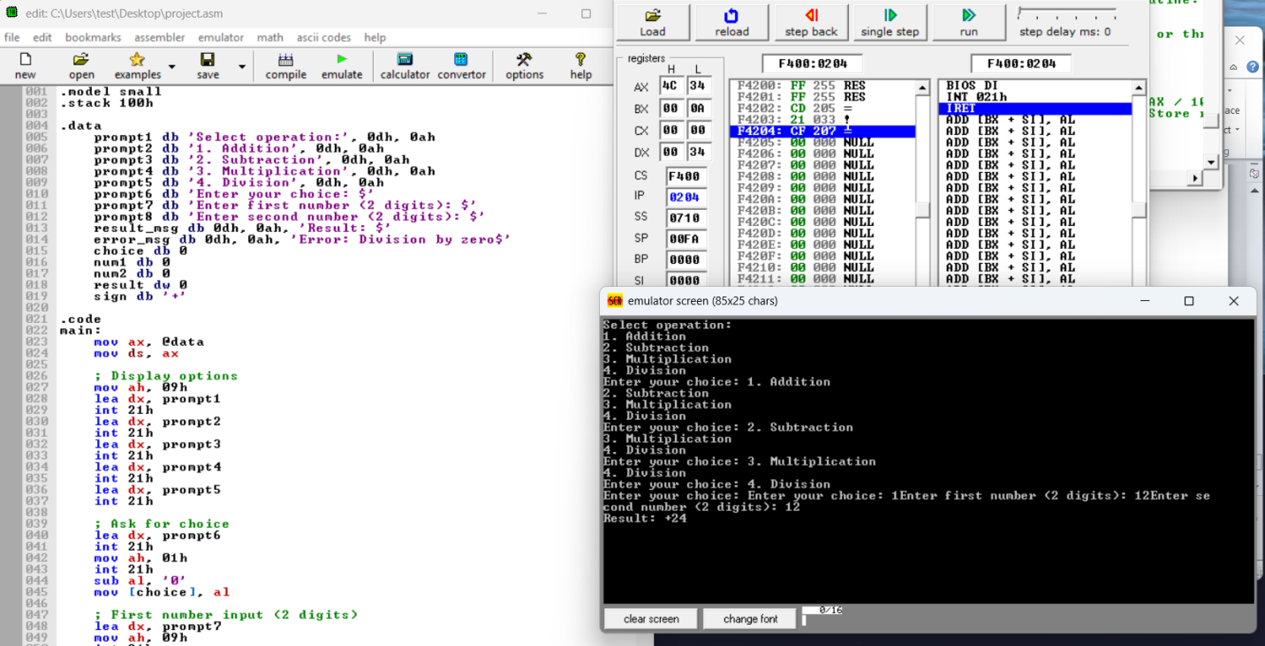  
  
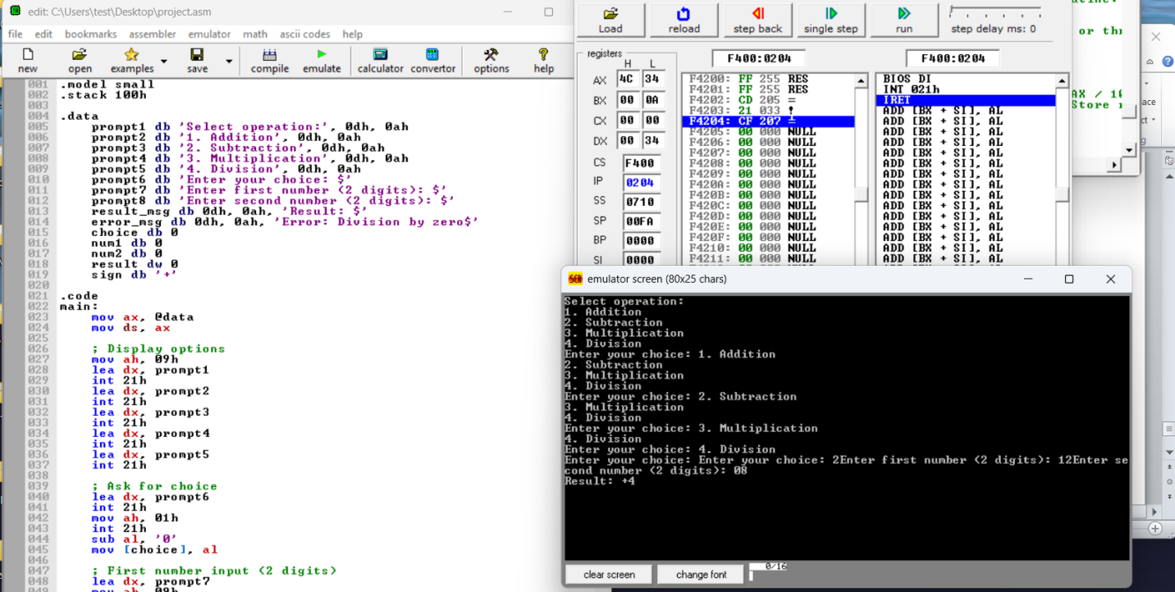  
  
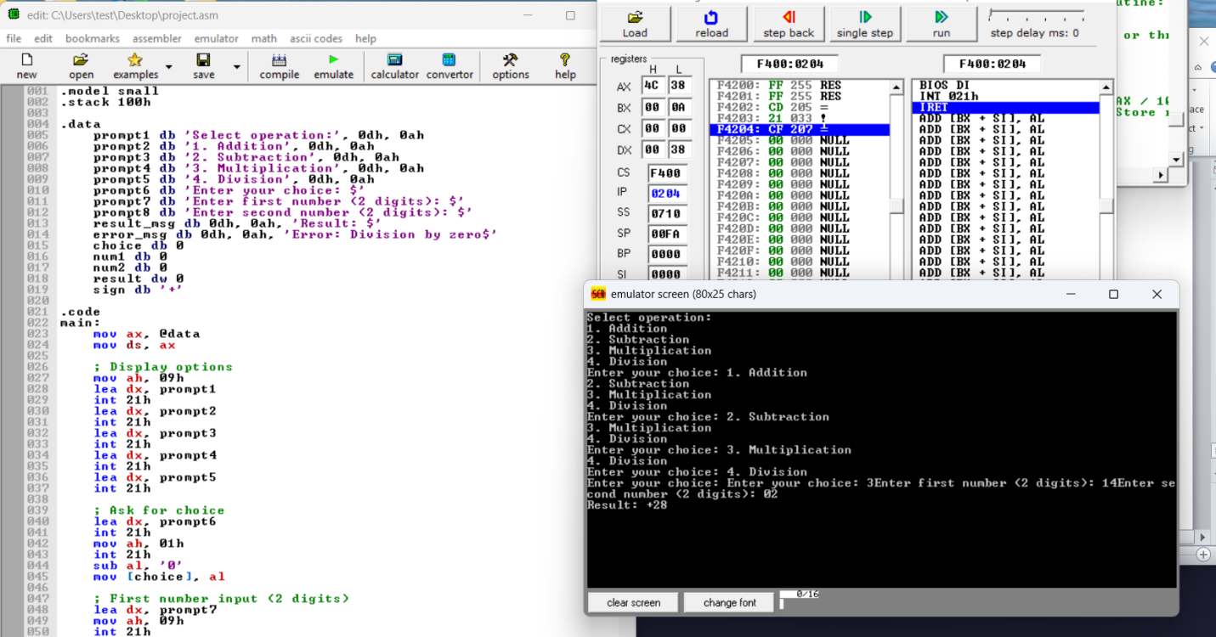  
  
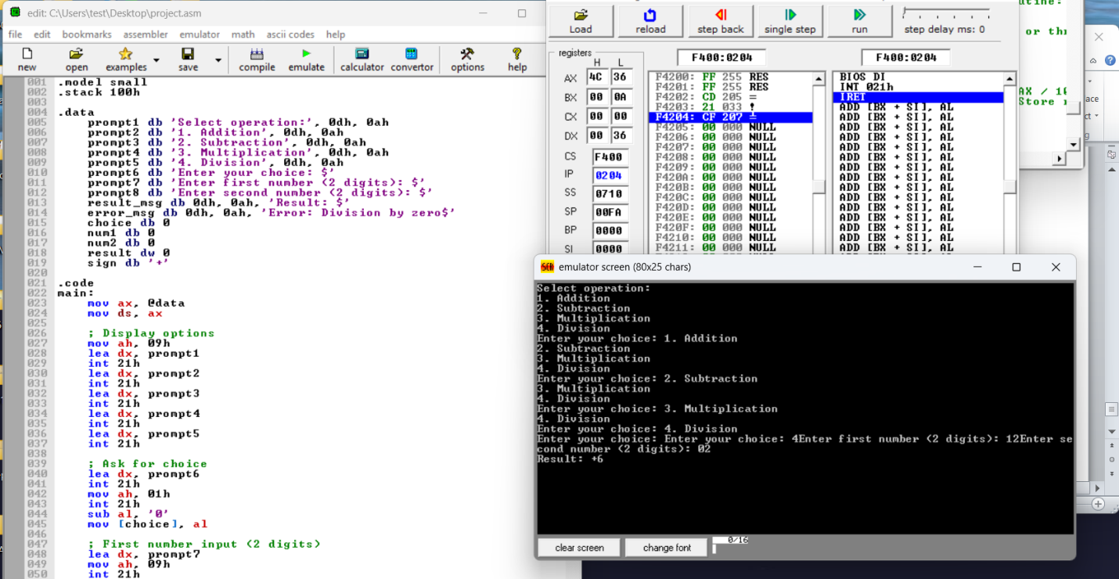**

### 6. ****Challenges and Solutions****

#### **a. Challenges:**

* **Handling input and output in assembly language was challenging.**
* **Converting ASCII values to numbers and vice versa had to be done manually.**

#### **b. Solutions:**

* **A custom subroutine was written for ASCII-to-number conversion.**
* **Interrupts were used for input/output handling.**

### 7. ****Conclusion****

**This project successfully demonstrates the creation of a disk-based calculator that allows users to perform basic arithmetic operations on two-digit numbers. It serves as a practical example of assembly language programming and disk file handling.**